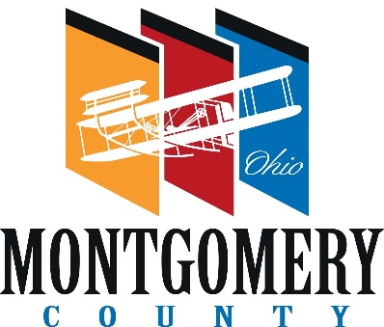 |  | PLANNING COMMISSION
 |  | MONTGOMERY COUNTY  ADMINISTRATION BUILDING  451 West Third Street, 10th Floor  Dayton, OH 45422-1110  937-225-4642 – phone  www.selectmcohio.com  www.mcohio.org | COUNTY COMMISSIONERS  Carolyn Rice  Judy Dodge  Mary A. McDonald  COUNTY ADMINISTRATOR  Michael B. Colbert  EXECUTIVE DIRECTOR  Tawana Jones  PLANNING MANAGER  Gwen Eberly  PRINCIPAL PLANNER  Larry Weissman, AICP  PLANNING COMMISSION SECRETARY  Erin Doherty

M E M O R A M D U M
FROM: Erin Doherty, Planning Commission Secretary
DATE: December 2, 2025
SUBJECT: 2026 Closing Dates for Case Submissions and Planning Commission Dates
The following is a list of dates for the Planning Commission’s regular meetings and the closing dates for case submission. If the case is submitted after the closing date, it will go on to the following month’s meeting agenda.

Case Submission Closing Dates P.C. Meeting Dates

Wednesday, December 24, 2025 Thursday, January 8, 2026
Wednesday, January 28, 2026 Thursday, February 12, 2026
Wednesday, February 25, 2026 Thursday, March 12, 2026
Wednesday, March 25, 2026 Thursday, April 9, 2026
Wednesday, April 29, 2026 Thursday, May 14, 2026
Wednesday, May 27, 2026 Thursday, June 11, 2026
Wednesday, June 24, 2026 Thursday, July 9, 2026
Wednesday, July 29, 2026 Thursday, August 13, 2026
Wednesday, August 26, 2026 Thursday, September 10, 2026
Wednesday, September 23, 2026 Thursday, October 8, 2026
Wednesday, October 28, 2026 Thursday, November 12, 2026
Wednesday, November 25, 2026 Thursday, December 10, 2026
Wednesday, December 23, 2026 Thursday, January 7, 2027

