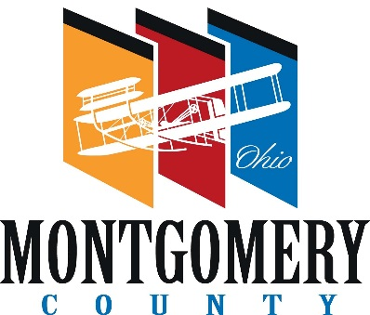 |  | PLANNING COMMISSION
 |  | MONTGOMERY COUNTY  ADMINISTRATION BUILDING  451 West Third Street, 10th Floor  Dayton, OH 45422-1110  937-225-4642 – phone  www.selectmcohio.com  www.mcohio.org | COUNTY COMMISSIONERS  Carolyn Rice  Judy Dodge  Deborah A. Lieberman  COUNTY ADMINISTRATOR  Michael B. Colbert  EXECUTIVE DIRECTOR  Tawana Jones  PLANNING MANAGER  Gwen Eberly  PRINCIPAL PLANNER  Larry Weissman, AICP  PLANNING COMMISSION SECRETARY  Erin Doherty

M E M O R A M D U M
FROM: Erin Doherty, Planning Commission Secretary
DATE: December 9, 2024
SUBJECT: 2025 Closing Dates for Case Submissions and Planning Commission Dates
The following is a list of dates for the Planning Commission’s regular meetings and the closing dates for case submission. If the case is submitted after the closing date, it will go on the following month’s meeting agenda.

Case Submission Closing Dates P.C. Meeting Dates

Tuesday, December 24, 2024 Thursday, January 9, 2025
Wednesday, January 29, 2025 Thursday, February 13, 2025
Wednesday, February 26, 2025 Thursday, March 13, 2025
Wednesday, March 26, 2025 Thursday, April 10, 2025
Wednesday, April 30, 2025 Thursday, May 8, 2025
Wednesday, May 28, 2025 Thursday, June 12, 2025
Wednesday, June 25, 2025 Thursday, July 10, 2025
Wednesday, July 30, 2025 Thursday, August 14, 2025
Wednesday, August 27, 2025 Thursday, September 11, 2025
Wednesday, September 24, 2025 Thursday, October 9, 2025
Wednesday, October 29, 2025 Thursday, November 13, 2025
Wednesday, November 26, 2025 Thursday, December 11, 2025

