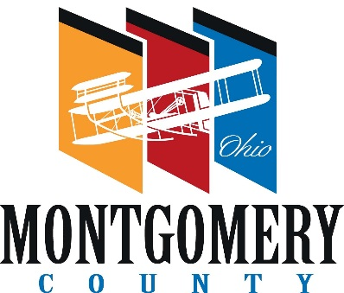 |  | PLANNING COMMISSION
 |  | MONTGOMERY COUNTY  ADMINISTRATION BUILDING  451 West Third Street, 10th Floor  Dayton, OH 45422-1110  937-225-4642 – phone  www.selectmcohio.org  www.mcohio.org | COUNTY COMMISSIONERS  Carolyn Rice  Judy Dodge  Deborah A. Lieberman  COUNTY ADMINISTRATOR  Michael B. Colbert  EXECUTIVE DIRECTOR  Tawana Jones  PLANNING MANAGER  Gwen Eberly  PRINCIPAL PLANNER  Larry Weissman, AICP  PLANNING COMMISSION SECRETARY  Erin Doherty

M E M O R A M D U M
FROM: Erin Doherty, Planning Commission Secretary
DATE: October 3, 2023
SUBJECT: 2024 Closing Dates for Case Submissions and Planning Commission Dates
The following is a list of dates for the Planning Commission’s regular meetings and the closing dates for case submission. If the case is submitted after the closing date, it will go on the following month’s meeting agenda.

Case Submission Closing Dates P.C. Meeting Dates

Wednesday, December 27, 2023 Thursday, January 11, 2024
Wednesday, January 24, 2024 Thursday, February 8, 2024
Wednesday, February 21, 2024 Thursday, March 7, 2024
Wednesday, March 27, 2024 Thursday, April 11, 2024
Wednesday, April 24, 2024 Thursday, May 9, 2024
Wednesday, May 29, 2024 Thursday, June 13, 2024
Wednesday, June 26, 2024 Thursday, July 11, 2024
Wednesday, July 24, 2024 Thursday, August 8, 2024
Wednesday, August 28, 2024 Thursday, September 12, 2024
Wednesday, September 25, 2024 Thursday, October 10, 2024
Wednesday, October 23, 2024 Thursday, November 7, 2024
Wednesday, November 27, 2024 Thursday, December 12, 2024

